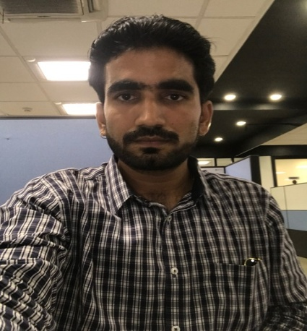****

**Date / Place of birth** 20/04/1990 Indore

**Nationality**

India

**Pen Card**

BCNPD0524Q

**Skills**

SQL



Java/Multithreading/Collection



Micro Services/Spring Boot



CI/CD/Git/SVN



Docker/Shell Scripting



Elastic Search



Angular



**Akash Dubey**

138 Brahma Bagh colony marimata square Indore 452006

8871579244 akki136@gmail.com

**Profile**

“*Leading Senior Software Developer and Engineer with 8.5 years of work experience leading* *developing team of size 4 from last 2 years. I enjoy coding, testing, and integration. Seeking new challenges and opportunities to leverage. I am an experienced in working on AWS and microservices also in J2EE. Holds a B.E. degree in CSE with many software competitions win in academic time.* “

**Employment History**

**Clear-Trail Technologies Pvt. Ltd (Senior Software Engineer)**

Jan 2018 — Present

I am working here as Senior Software Engineer cum full stack developer from last three years. initially I was single contributing member of product team. now I have 4-members team. We deal with law forensics domain for multiple movement organizations. products I worked are :-

* **Investigation workbench**: - Development, Unit Testing, Production Support

**Tech Stack Used: - (Spring Boot, Micro services, Struts Core Java, Multithreading, Angular 7, MySQL, Collections, Elastic Search, RabbitMQ)**

* **CARBON**: -Development, Lead Team, TDD, Production support

**Tech Stack Used: - (Spring Boot, Micro services, Struts Core Java, Socket Programming, Multithreading, Angular 7, Elastic Search, Collections, RabbitMQ)**

* **Singular**: - Development, Lead Team, TDD, Production support

**Tech Stack Used: - (Spring, Spring Boot, Micro services, Struts Core Java, Socket Programming, Multithreading, Angular 7, Solr, Kafka, Collections)**

* **Snapshot**: - Development, Lead Team, TDD, Production support

**Tech Stack Used: - (Spring, Spring Boot, Micro services, Struts Core Java, Socket Programming, Multithreading, Angular 7, Elastic Search, RabbitMQ, Collections)**

**Academic Achievements**

Tv/news paper interview for my work recognition

**Skills**

MongoDB



Quarkus



RABBIT MQ



CI/CD/Git/SVN



Kafka/scala



Spring Job and batch Processing



JavaScript/jQuery



**Yash Technologies Pvt. Ltd (Senior Software Engineer)**

March 15 Jan — Jan 2018

I was working here as Senior Software Engineer for Agriculture Domain.

I was initially the part of 4-member team. then I switch to team of 24 which was big but divided in segments for a particular purpose. here I was star member of team for continued two years. Products I worked here are: -

* **Prism**: - Development, Unit Testing, TDD, Production support

**Tech Stack Used: - (J2EE, Struts Core Java, Multithreading, MySQL, Collections)**

* **Farmers First**: - Development, Unit Testing, TDD, Production support

**Tech Stack Used: - (Spring Boot, Angular JS, Micro Services, Rest API, Core Java, Multithreading, Cassandra, Postgres, AWS, Elastic Search, Collection, RabbitMQ, Postgres)**

* **Farm Rise**: - Development, Unit Testing, TDD, Production support

**Tech Stack Used: - (Spring Boot, Micro Services, Rest API, Core Java, Multithreading, Cassandra, Postgres, AWS, Collection, Mongo DB)**

**CSC India Pvt. Ltd (Prof 1: Product Developer)**

April 2014 — March 2015

I was working here as Product developer in insurance domain. I had team of 8 members. Product I worked on:

**Integral Admin**: - Development, Unit Testing, TDD, Production support

**Tech Stack Used: - (J2EE, Core Java, Multithreading, Oracle, Collections)**

**Education**

**B.E. RGPV 68%**

**12th MP BOARD 68%**

**10th MP BOARD 76%**